Figure 1. Locations of 18 major Fraser Sockeye salmon stocks where spawning data were collected. Color indicate different run type, including Early Stuart (red); Early Summer run (green): Bowron, Fennel (Upper Barriere), Scotch, Nadina, Pitt, Seymour, Gates; Summer run (blue): Chilko, Quesnel, Late Stuart, Stellako, Raft; Late run (purple): Late Shuswap, Cultus, Portage, Weaver and Birkenhead.

Figure 2. Interannual variation of 10 environmental and ecological variables from 1050-2020, including Entrance Island sea surface temperature (Ei.SST, unit in oC), Pine Island sea surface temperature (Pi.SST, oC), mean and peak Fraser River discharge at Hope (unit m3/s), Pacific Decadal Oscillation (PDO), Gulf of Alaska sea surface temperature(GOA.SST, oC), North Pacific sockeye, chum, pink salmon abundance (catch plus escapement, number in million), and total salmon (sum of sockeye, chum and pink).

Figure 3. Relative ranking among all 37 forecast models for all 18 stocks. The relative ranking (scale of 0-1) was derived from the overall ranking table by dividing the rank of a model by the number of models evaluated for that individual stock. Blank indicates the model was not applicable to the stock.

Figure 4. Correlation (*R*) between the 2022 forecast and forecasts from all 37 models versus observations for all 18 Fraser sockeye stocks.

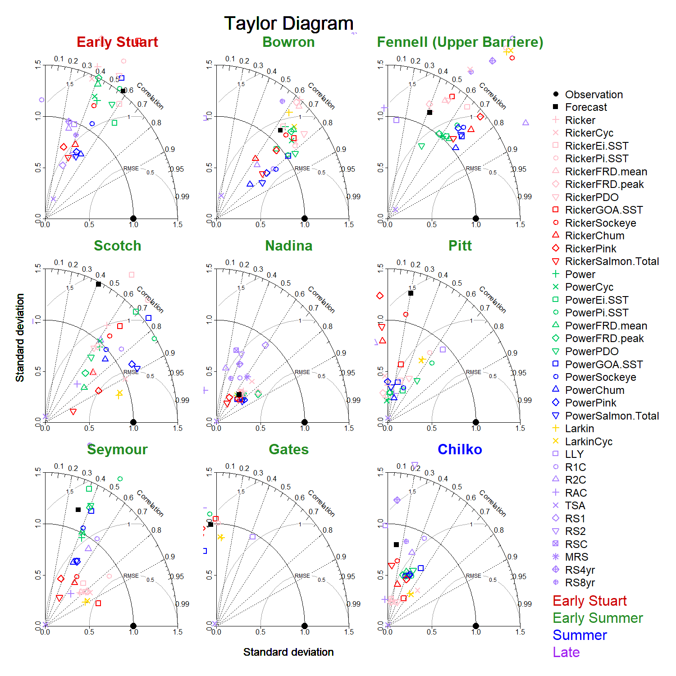

Figure 5a. Taylor diagrams of nine sockeye stocks including Early Stuart and Early Summer run: Bowron, Fennel (Upper Barriere), Scotch, Nadina, Pitt, Seymour, Gates; and Summer run: Chilko. Each diagram showing comparisons among 37 model forecasts. The observations of 12-year returns were normalized as the reference point or observation (solid black cycle on the x-axis). The distance from the origin is the normalized standard deviation with the scale of 0-1.5 and normalized observation being 1. The angle describes the correlation between model and observation from 0 to 1. The dashed semi-circles around reference point on the x-axis illustrate the root-mean-square error. Models with negative correlations are not shown for each stock. The closer the model is to the reference point, the better predictive power the model has.

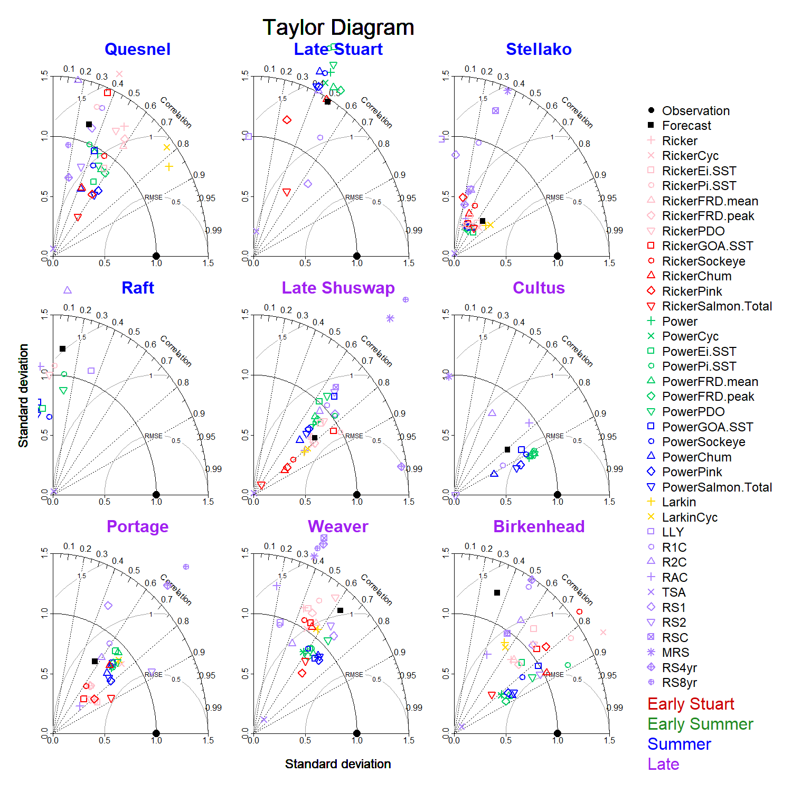

Figure 5b. Taylor diagrams of nine sockeye stocks including Summer run: Quesnel, Late Stuart, Stellako, Raft; and Late run: Late Shuswap, Cultus, Portage, Weaver and Birkenhead. Each diagram showing comparison among 37 model forecasts. The observations of 12-year returns were normalized as the reference point or observation (solid black cycle on the x-axis). The distance from the origin is the normalized standard deviation with the scale of 0-1.5 and normalized observation being 1. The angle describes the correlation between model and observation from 0 to 1. The dashed semi-circles around reference point on the x-axis illustrate the root-mean-square error. Models with negative correlations are not shown for each stock. The closer the model is to the reference point, the better predictive power the model has.

Figure 6. Comparisons among the 2022 forecast and the forecasts based on three top-ranked models based on either overall rank, standard deviation (*SD*), and correlation (*R*) or best root-mean-square error (RMSE) for three most abundant Fraser sockeye stocks, Chilko, Late Shuswap and Quesnel. Median forecast or 50 percentile (P50: solid black line) and forecast distribution (box: P25-P75, range: P10-P90) were compared with the actual 2022 returns (PSC preliminary results). \*The Chilko forecast is using a RickerEi model for age4 fish only, coupled with Sibling model for age5.